Please see below notes before start automation test

Select test case (class) to test :

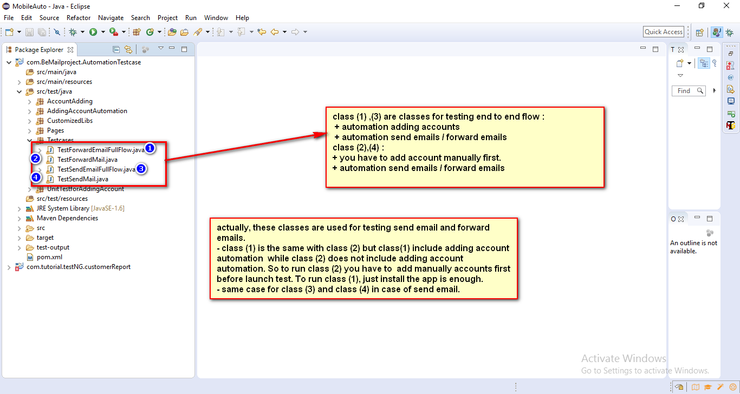

**To test send email : you can use test case (3) or (4).**

* Test case (3) : it will handle adding account automation. Means you do not have to add account manually.
* Test case (4) : it will not handle adding account automation. So you have to add account manually first before to run test case.

**Same case for test case (1) and test case (2), when you test forward emails.**

* Test case (1) : it will handle adding account automation. Means you do not have to add account manually.
* Test case (2) : it will not handle adding account automation. So you have to add account manually first before to run test case.

Prepare data in excel file before running test case

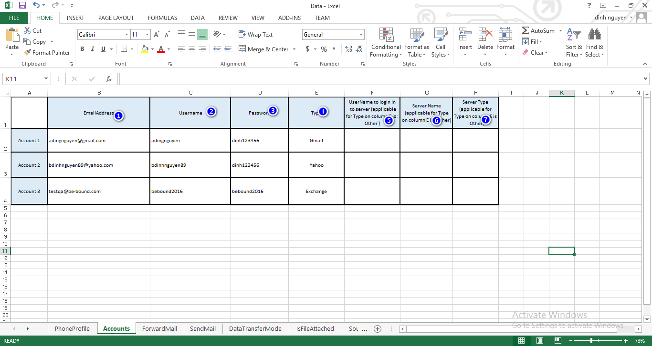

**Values in Accounts Sheet**

* Column (1) : the email address
* Column (2) : will the name before @ in the column.
  + Example : your email is : [testa@gmail.com](mailto:testa@gmail.com) then column (2) will be : testa
  + Or your email is : [testing@yahoo.com](mailto:testing@yahoo.com) then column(2) will be : testing
* Column (3) : password of your email
* Column (4) : you have to specify the email type
* Coulmn (5), (6),(7) : input only for case if column (4) value is Other.

**Values in Send mail sheet and forward email sheet**

Edit To and Forward column according the account 2 and account 3.

How to run test case

You can right click the test case and select run as testng

Or you can edit the xml file

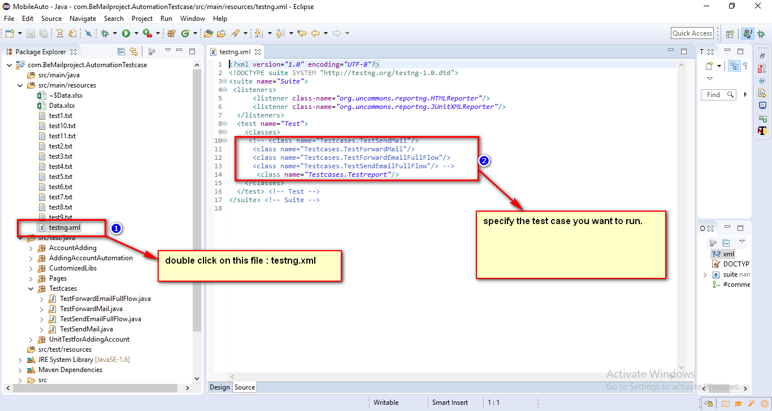

If you want to run test case 3 only at the same time you can edit the xml like that

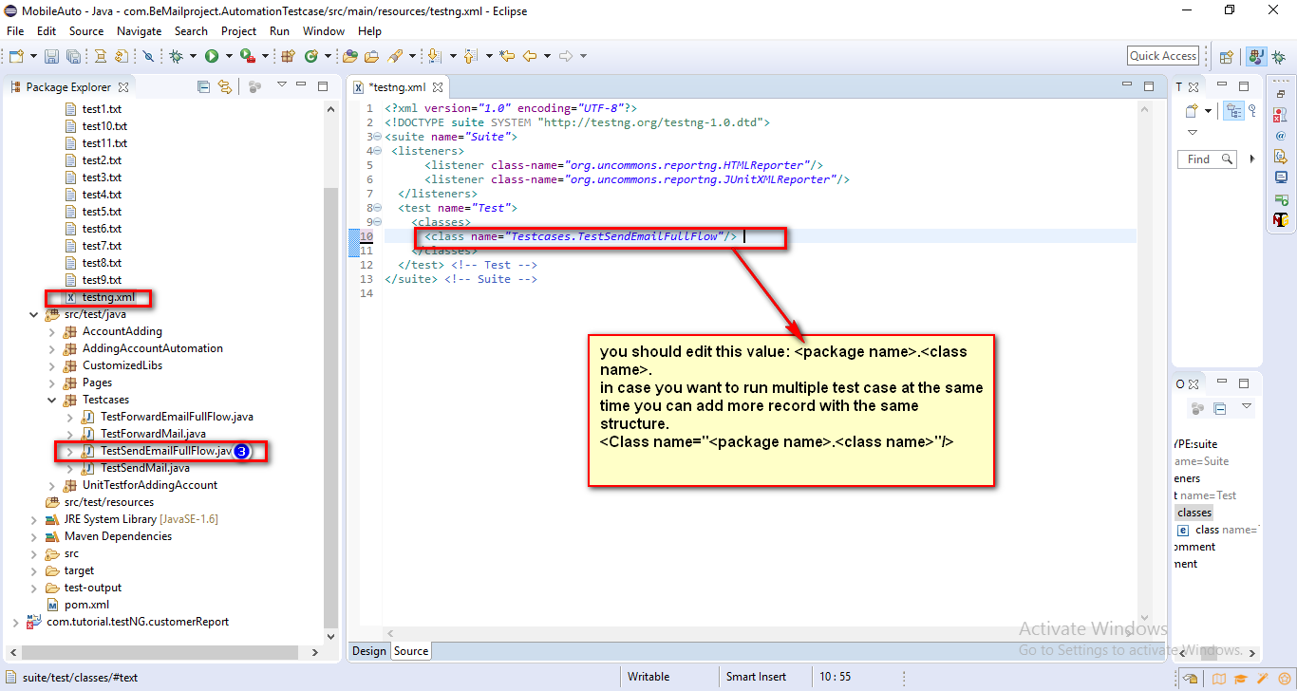

After edit xml file. You can right click xml file and select run as testng

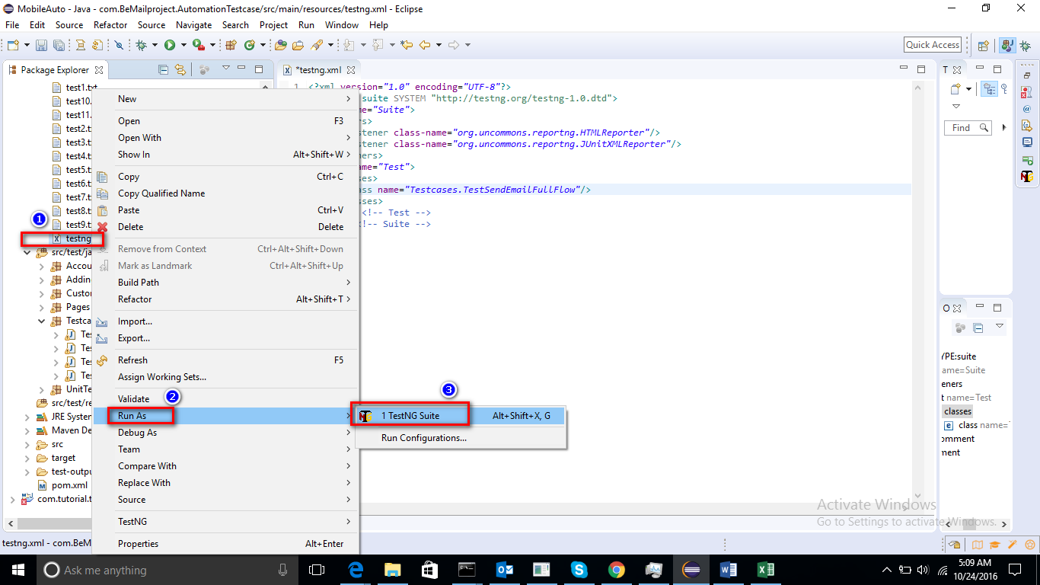

**How to check the report**

After run the test case you can check the report

* You can check the default report generated by testng

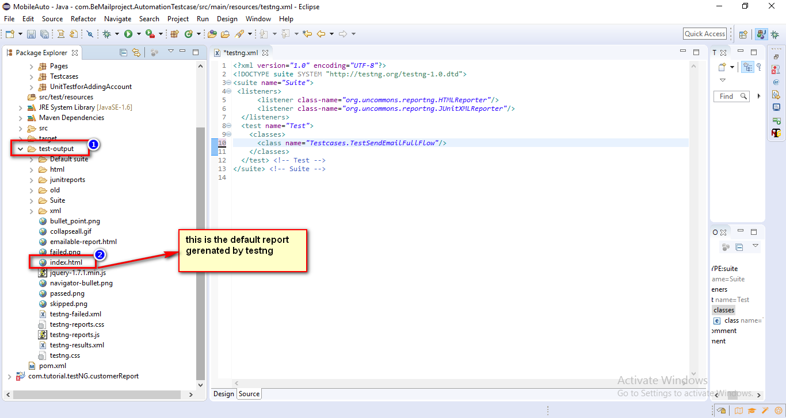

* Or you can check the customized report

